**31. Demonstrate processors, assertions, and timers in JMeter.**

**Processors:**

**Pre-processor:**

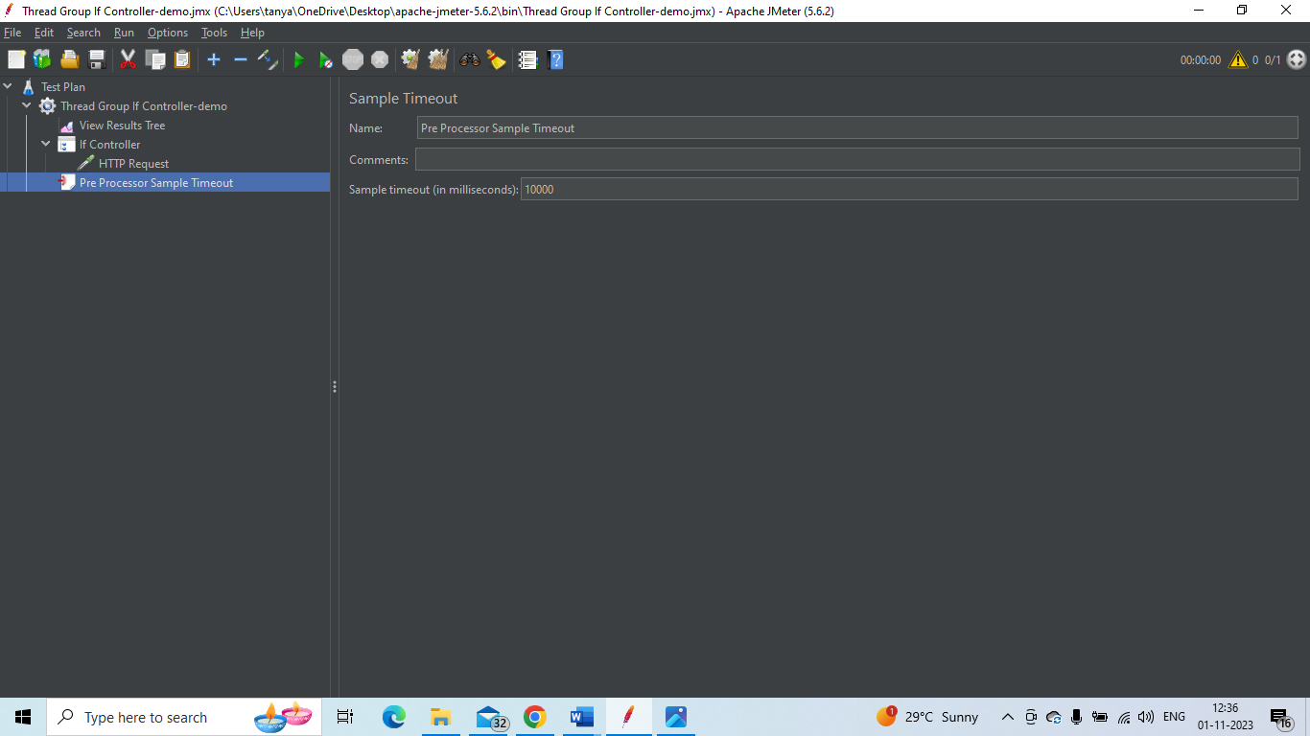

**Post-Processor:**

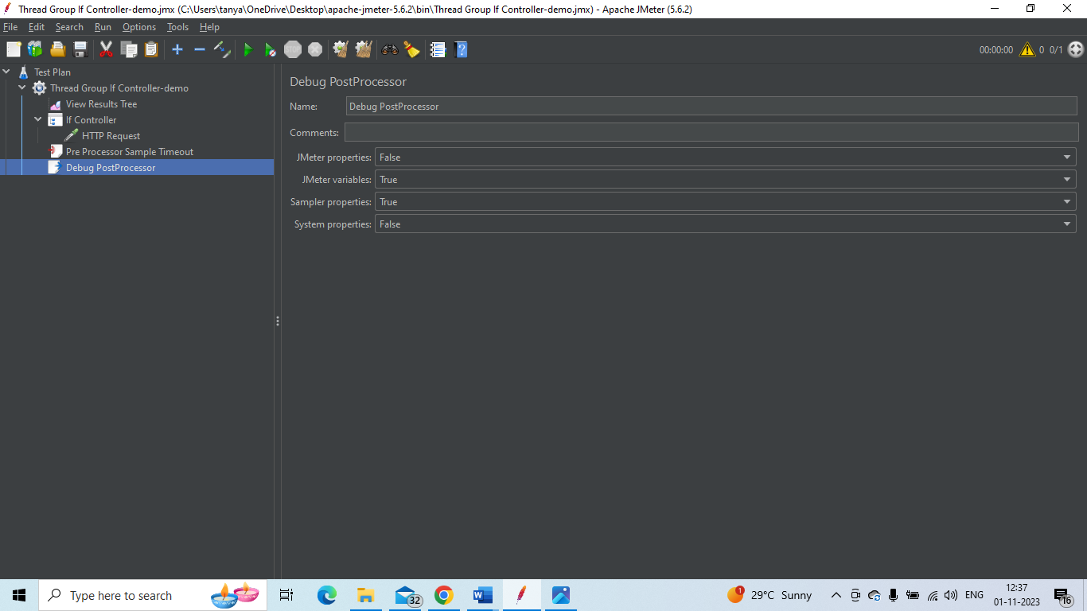

**Assertions:**

1. Response assertion:

Take the junit Sampler request again 🡪 right click on junit sampler and add 🡪 assertion 🡪 Response assertion

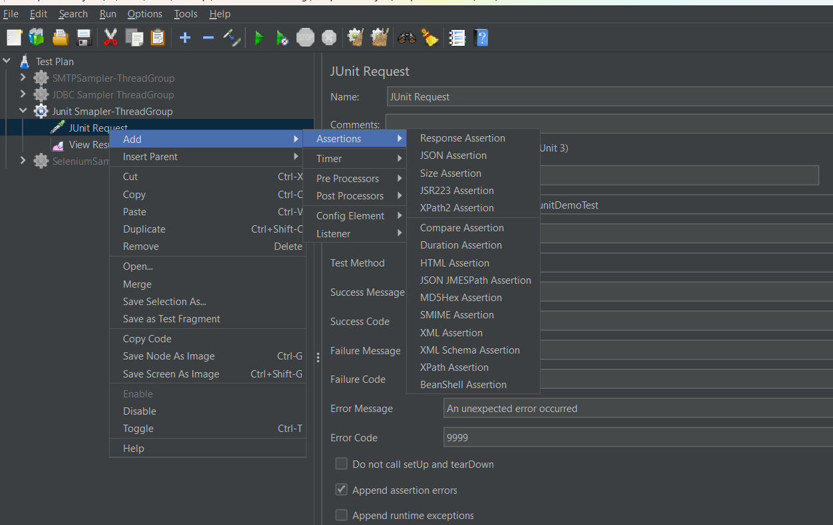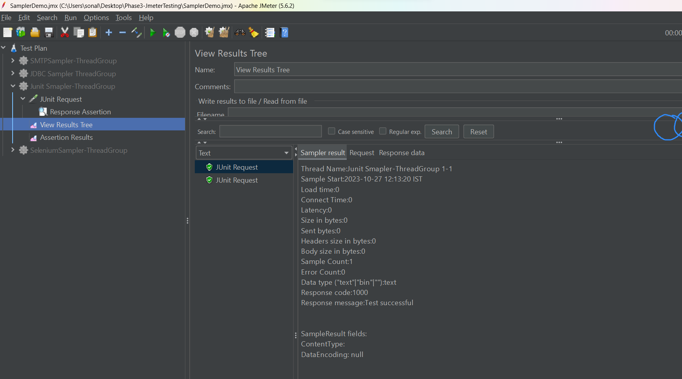

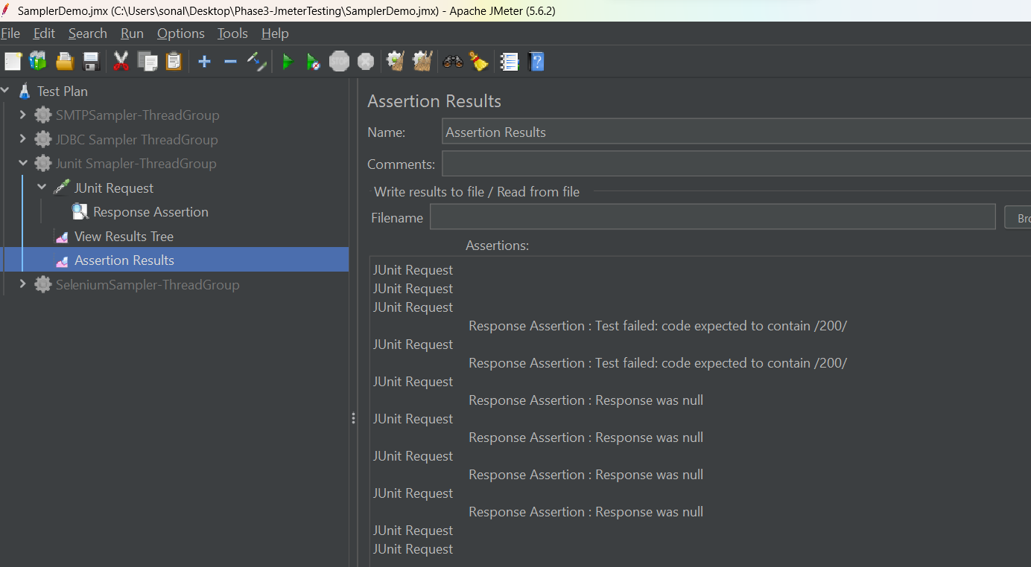

HTML Assertion

It captures errors and warnings on the HTML page that jmeter connects to

After which it can put those errors and warning in a file and save it.

Create a Thread group 🡪 add sampler HTTP request

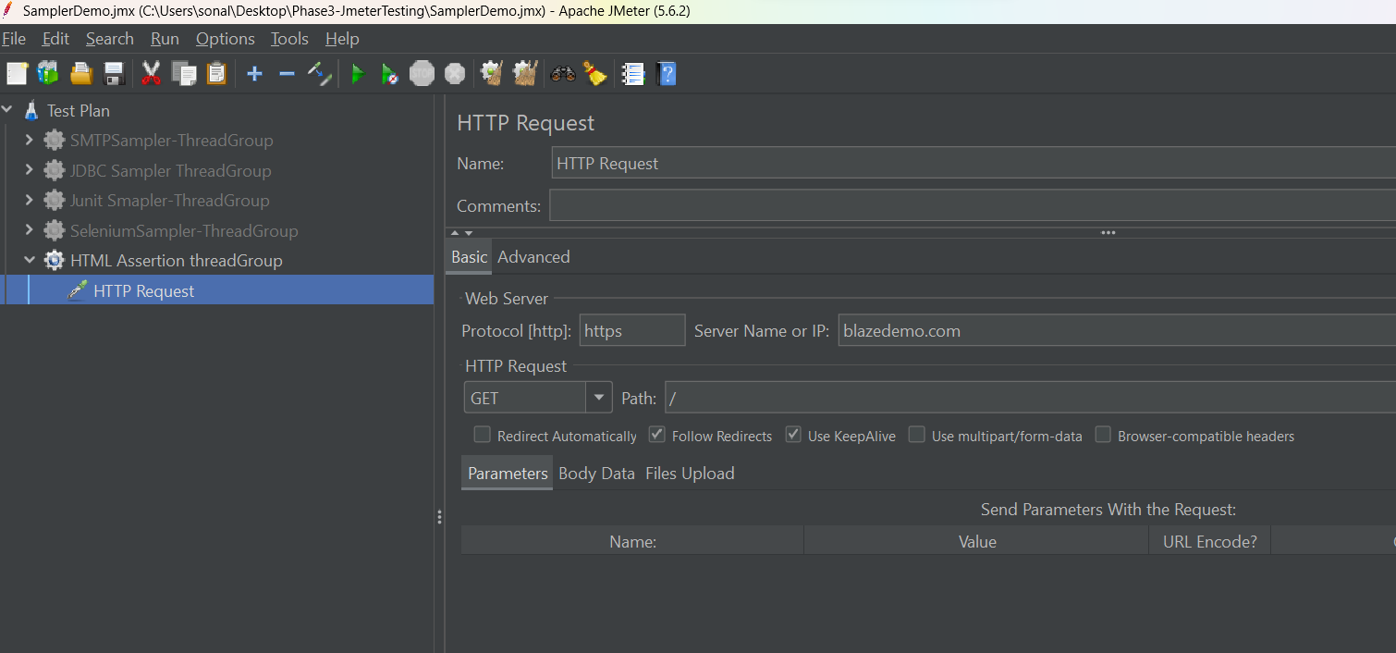

Add HTMl assertion to http sampler

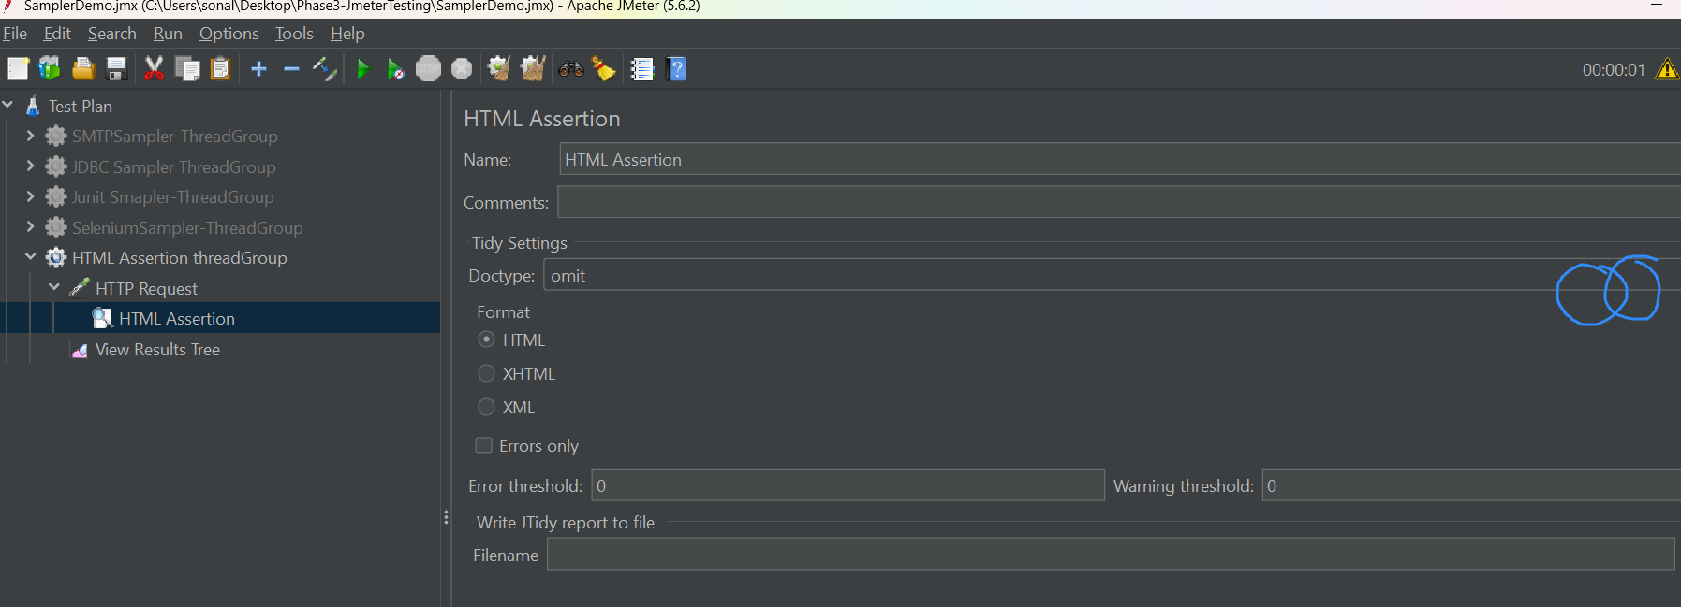

Create a new folder using browser button, also give the file name at the same time

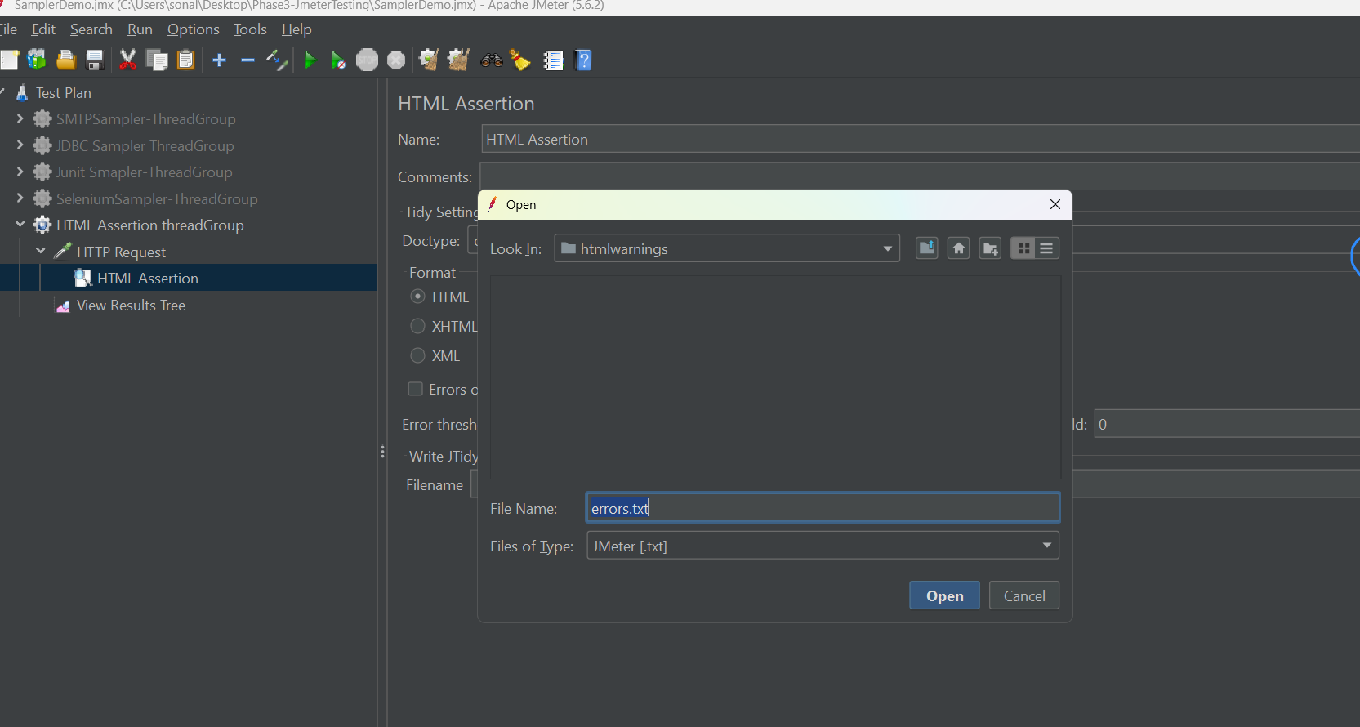

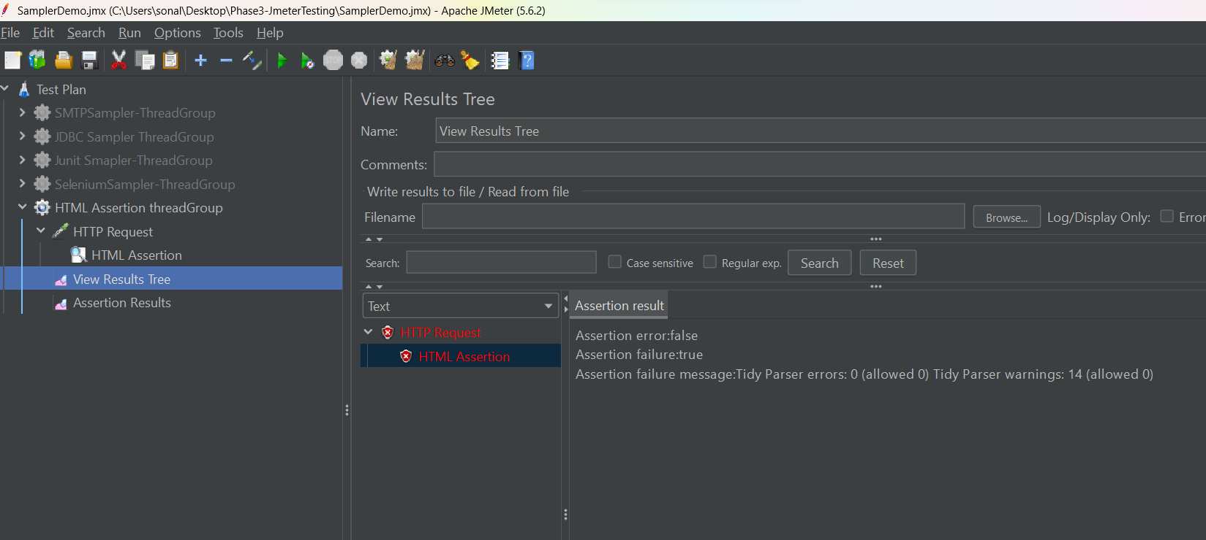

**Timers:**

Constant timers:

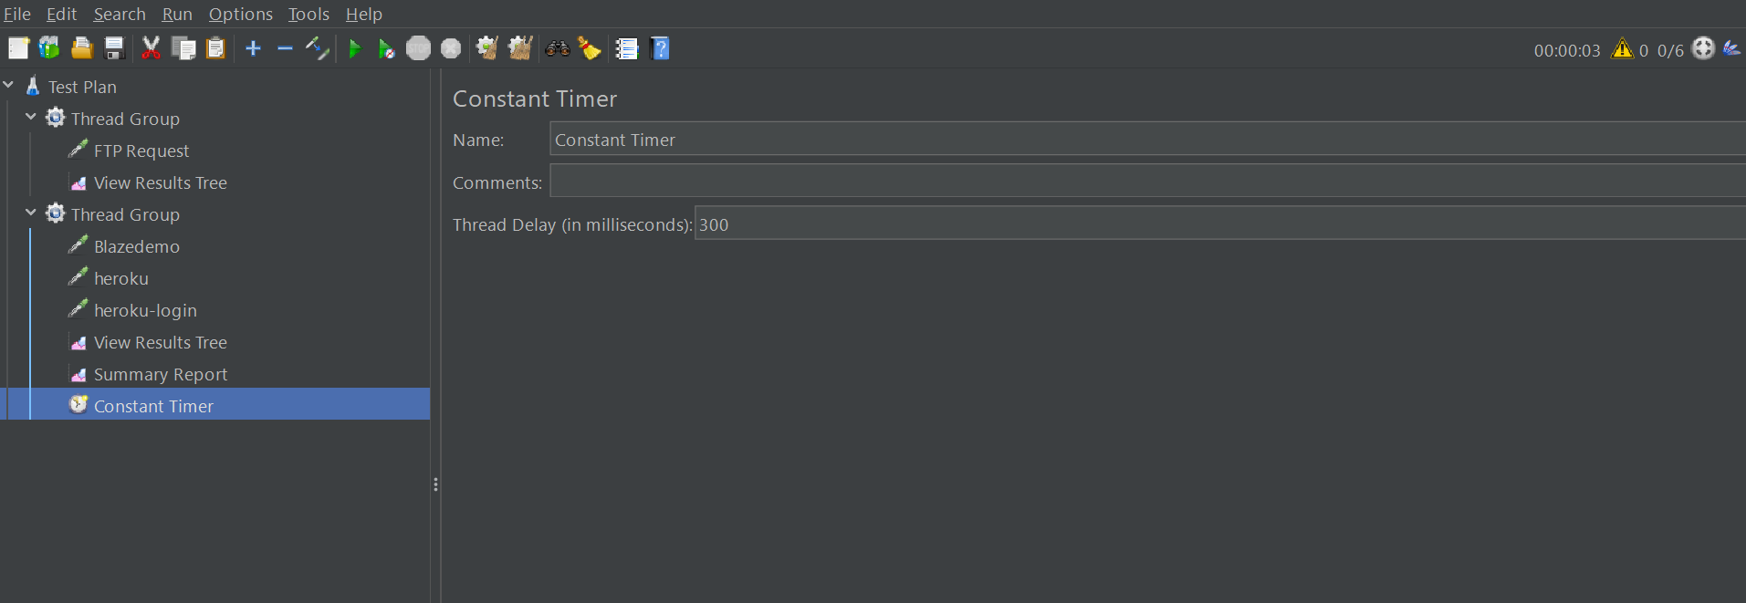

Uniform Random timer

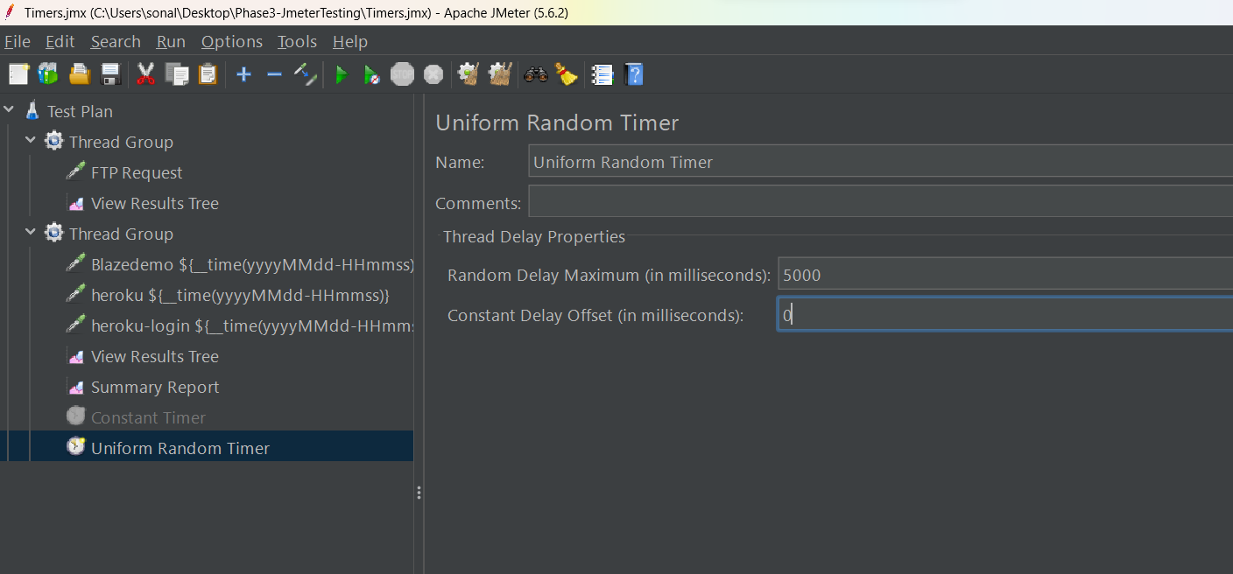

Gaussian Random timer

